1. How you will replace “has” with “have” in the current line ?

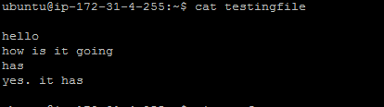

What are the various of replacing this has with have.

1. How will you insert a line , above the current line and below the current line ?

For ex : I want the above screenshot should be like below

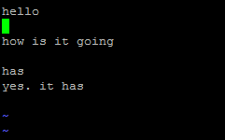

1. How do you abort an editing session, i.e, without saving the content ?
2. Name 3 ways of existing a vi session after saving your work ?
3. In the current line, how do you take your cursor to 40th character?

See the 2nd line which I have typed, it has more than 40 characters. You should move your cursor to 40th character directly



1. On the same above line, how will you move your cursor to the beginning of the line and end of the line ?
2. How do you combine five lines into a single line ?

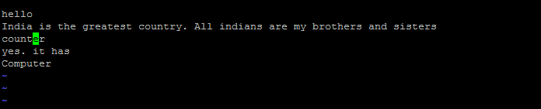

I want the answer should be like this



1. How will you search for a pattern “country” in the below file?

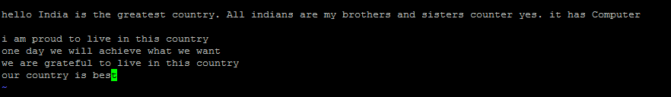

1. In the mid of your work in VI session, you wants to check how many users have logged in to the linux server? How will you check
2. Copy /etc/passwd to passwd in your home directory. Name the vi commands required to save the first 10 lines in passwd1, the next 10 in passwd2 and rest in passwd3.